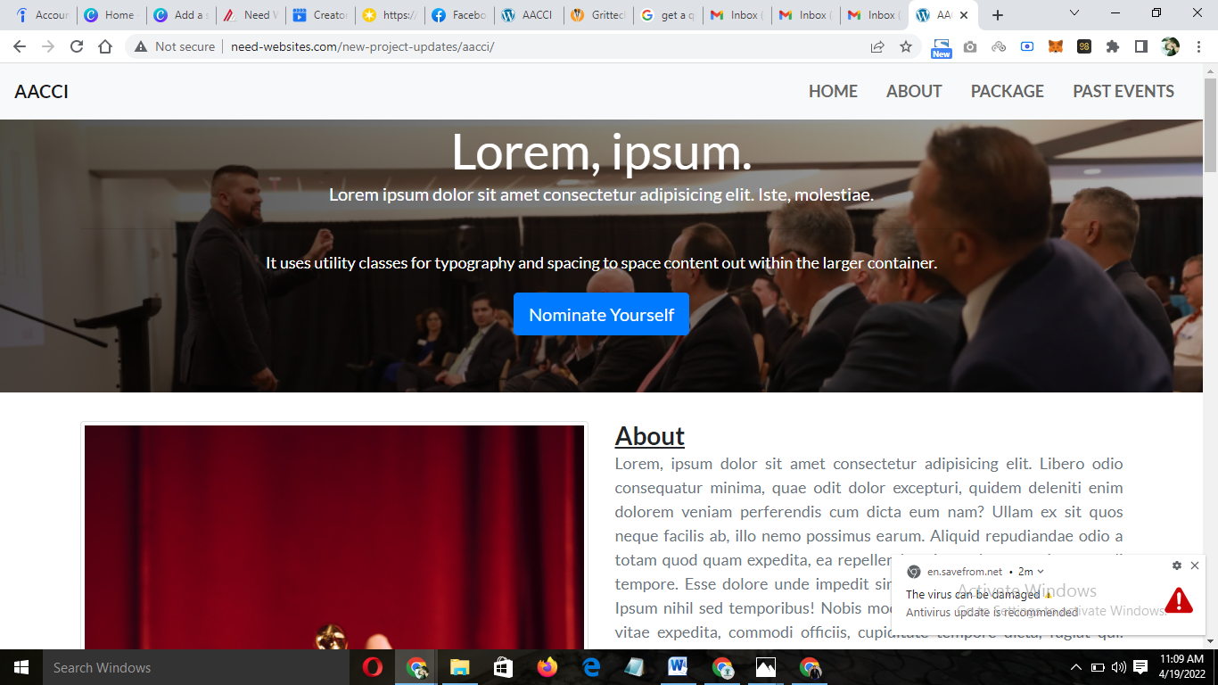

1. AACCI should be Parichay 3.0
2. Remove Lorem Ipsum and Dummy texts and place the Nominate Yourself button centrally (it should be aligned and look good and well placed.
3. Replace the Banner image with the image in the attachment.

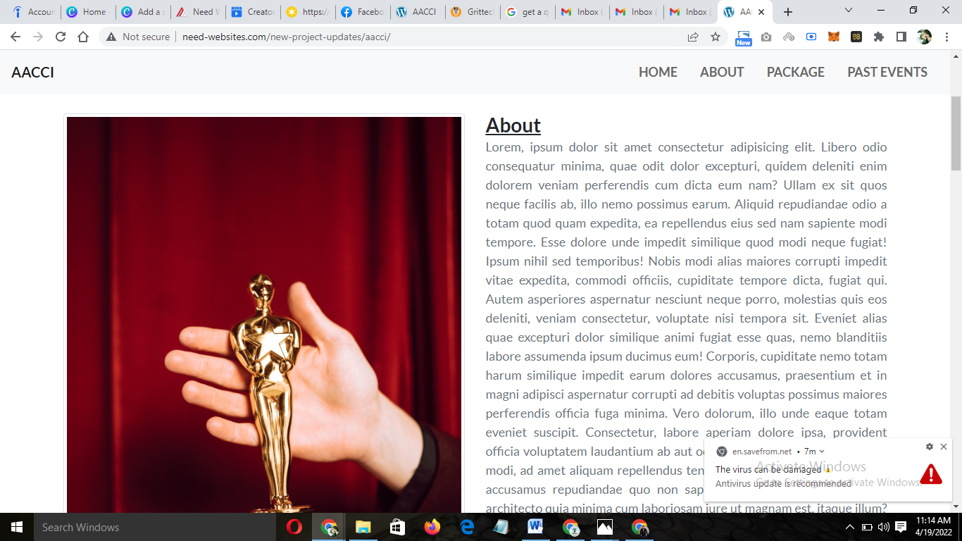

Reduce the size of this section

Replace the image with the award image in the year 2019

Below this section please add

Partners : Below which there will be logos of the partners

Sponsors: Add logo of the sponsors

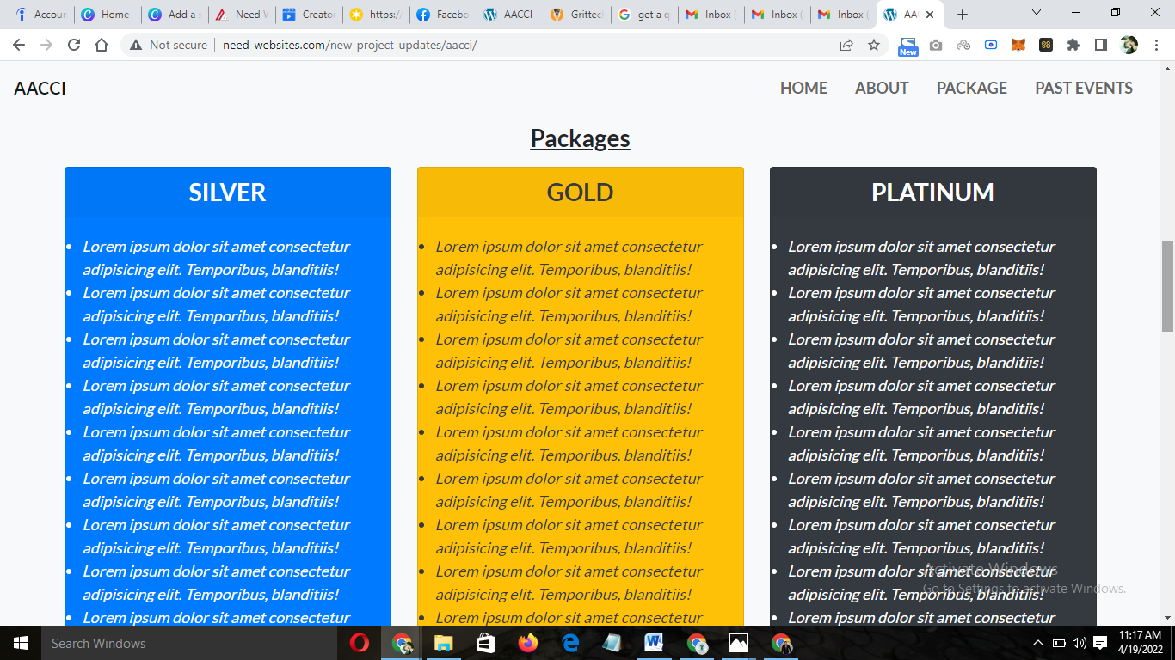

Please make these boxes more attractive right now this is not looking good.

The nominate button on being clicked should a form with name, business name contact information

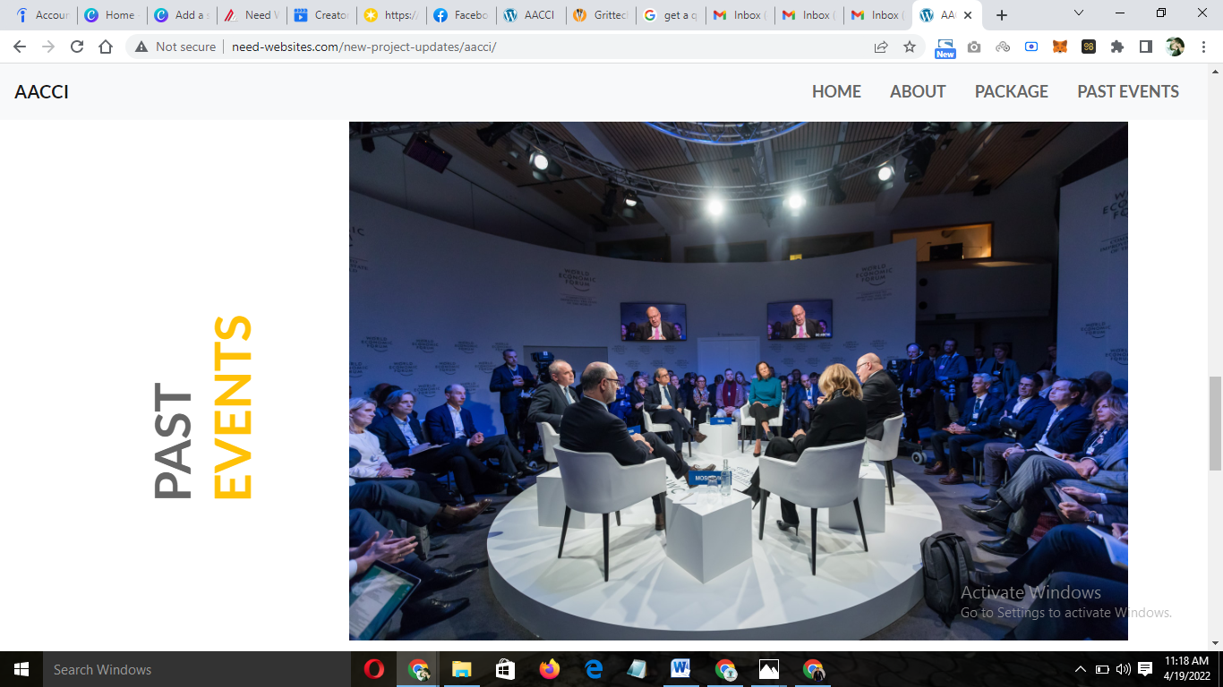

Please add all the images in the past event

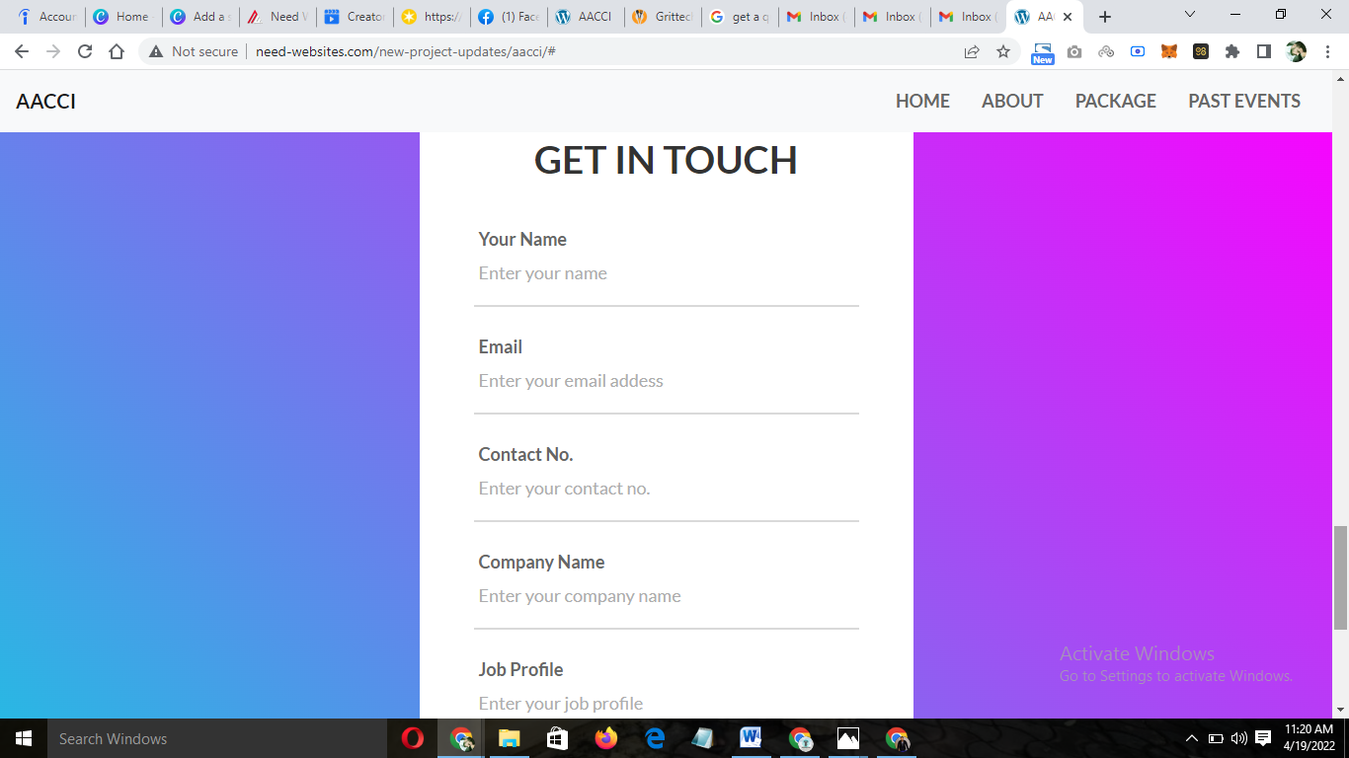

Please change this section with Media Partners and add the logo of Media

Use the logo of bidhannagartimes , zee 24 Ghonta… more will be added in days ahead.